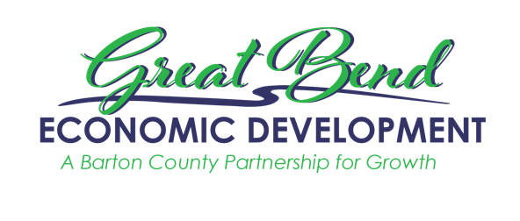
Great Bend Economic Development
3111 10th Street
Great Bend, KS 67530
(620) 796-2407
marketing@gbedinc.com
www.gbedinc.com

For Immediate Release:
October 27, 2022

Great Bend Economic Development received an award from The Kansas Department of Commerce at their To the Stars: Kansas Business Awards Banquet

On October 20, 2022, the Kansas Department of Commerce held its annual To the Stars: Kansas Business Awards banquet in Topeka. Great Bend Economic Development was nominated and won the North Central Region in the category, Apprenticeship Champions and Partners. Nominated by Lana Gordon, Kansas Grant Manager for Hamilton-Ryker TalentGro division, this award is given to companies that excel in providing registered apprenticeship programs in Kansas. Sara Arnberger, GBED’s President, exemplifies this award as she has and continues to connect businesses with the resources they need to create apprenticeship programs. In making these connections, Hamilton-Ryker assisted KMW Loaders, one of Great Bend’s manufacturers, in creating an apprenticeship program. The KMW Learning Academy began its inaugural class with a full roster and a waiting list for those not able to begin in September.

Lana Gordon said, “Sara has a unique understanding of how to create a network of business leaders, the local workforce board, the City of Great Bend, County, Community Colleges, the High School, and other community leaders to create a meaningful pipeline to promote the apprenticeship model. Sara has joined forces with Hamilton Ryker's TalentGro Division, one of the Intermediaries for the Kansas SAEEI apprenticeship grant to assist with building collaboration to support the region’s businesses in their quest to attract, train and retain their workforce.”

Craig VanWey, In-State Business Development Manager, said that the To the Stars awards allow the Kansas Department of Commerce the ability to highlight some of the success stories taking place in all parts of Kansas. Accepting the award in Topeka was Lee Ann June, GBED’s Communications Director, as Sara Arnberger, GBED President was on her honeymoon. Upon her return to the office and hearing of the award, Sara said, “It’s such an honor to be recognized for our work on apprenticeships. We at GBED believe that apprenticeships have an integral role to create a thriving workforce in Barton County.”

Apprenticeships are generally regarded as a positive program to help workers gain experience and knowledge; they need to be hirable members of the workforce. To learn more about apprenticeship programs, please contact GBED via email at marketing@gbedinc.com or by calling 620-796-2407.

About GBED (Great Bend Economic Development):
Our goal is to sustain long-term economic health and vitality of the County through the retention, expansion, and attraction of businesses and development that enhance property values, increase personal income, and make a positive contribution to the quality of life of the citizens of Barton County.

Great Bend Economic Development leads the charge in creating workforce initiatives to sustain our current employers as well as initiatives that will help to support new employers that move to the community. Employers and jobseekers are encouraged to reach out to GBED with questions and concerns and GBED will either pair you up with a workforce partner to help you accomplish your goals, or work with you one-on-one to create solutions and positive outcomes. Together we will create a strong and sustainable workforce pipeline that will enable us to continue to grow Barton County.

