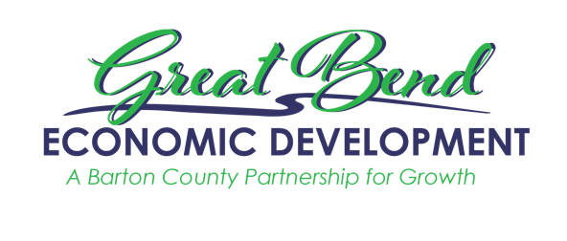
Great Bend Economic Development
3111 10th Street
Great Bend, KS 67530
(620) 796-2407
marketing@gbedinc.com
www.gbedinc.com

For Immediate Release:
November 19, 2022

Great Bend Economic Development launches entrepreneurship competition, IGNITE Rural Business, to bring businesses to Barton County

On November 19, 2022, Great Bend Economic Development launches a new competition for entrepreneurs to open/start a business in Barton County. New inventions/businesses are encouraged to apply as well as startups. This competition exists to empower, support, and cultivate entrepreneurs. Here in Barton County, we strive to champion creativity and innovative thinking and complement a project or idea with the tools, resources, and investment necessary to see it thrive. We aim for this competition to be the first of many efforts to continue that mission in a positive and impactful way.

Those interested in competing will have the opportunity for exposure of their business, assistance from local business professionals, and three businesses are walking away with substantial prize money. With an emphasis on bringing business to Barton County, the Ignite committee is partnering with NetworkKansas and the Small Business Development Center. NetworkKansas has facilitated the use of Venture Dash as the contestant portal. Venture Dash allows contestants to submit materials and track their progress. In addition to weighing in on the competition, both NetworkKansas and the Small Business Development Center connect contestants to mentors and assistance with their business plans.

IGNITE Rural Business is launching Friday in celebration of Global Entrepreneurship Week. This week the world is celebrating the entrepreneurship spirit with events like the IGNITE Rural Business competition and a push for entrepreneurial ecosystems. For more information about Global Entrepreneurship Week visit www.genglobal.org. If you are looking for local inspiration, GBED has interviewed some of Barton County’s entrepreneurs and posted those videos on the Great Bend Economic Development YouTube Channel, as well as @GBEDinc on TikTok.

The IGNITE competition
In round one, all competitors submit the necessary materials through the Venture Dash platform. The link to the portal is on the GBED website. In round two, the competition pool is narrowed. Businesses will be selected to engage in a one-on-one meeting with a business planning professional. To have viable businesses in the next round, each contestant will be paired with a local business mentor in a category of the contestant's desire. Contestants will have a final Q&A with the IGNITE Team before the final five contestants are chosen for the live IGNITE Finale event in October 2023.

A few extra takeaways for those interested in entering the competition include startups (Startups are considered businesses less than 5 years old and with 10 or fewer employees) and all applicants must be 18 years and older. The application deadline is June 30th, 2023. Rules, eligibility requirements, guidelines, and applications are live and available on www.gbedinc.com/IGNITE.

The live IGNITE Rural Business competition finale (on October 5th, 2023) will have participants pitching to our Jury in front of a live audience at the Crest Theater in Great Bend, then our Jury will conduct a Q&A session following every pitch. Composed of experts from the private and/or public sectors with relevant business experience, the jury will base their decisions on innovation, creativity, long-term business strategy, and viability. The winner of the Grand Finale will win $50,000! Second place is awarded $30,000, and third place gets $10,000. Those following along the journey of the IGNITE Rural Business competition will vote online for the People’s Choice Award and award a business with $5,000.

How to participate
If you like more information about being a sponsor of the live event or becoming a business mentor, please reach out to GBED staff at marketing@gbedinc.com or by calling 620-796-2407.

About GBED (Great Bend Economic Development):
Our goal is to sustain Barton county's long-term economic health and vitality through the retention, expansion, and attraction of businesses and development that enhance property values, increase personal income, and positively contribute to the citizens' quality of life of Barton County.

Great Bend Economic Development leads the charge in creating workforce initiatives to sustain our current employers as well as initiatives that will help to support new employers that move to the community. Employers and jobseekers are encouraged to reach out to GBED with questions and concerns and GBED will either pair you up with a workforce partner to help you accomplish your goals, or work with you one-on-one to create solutions and positive outcomes. Together we will create a strong and sustainable workforce pipeline that will enable us to continue to grow Barton County.

